**Model Reference Adaptive Control (MRAC) for AUV**

Safa Bazrafshan

Independent Researcher

Email: safa.bazrafshan@gmail.com

ORCID: https://orcid.org/0009-0004-4029-9550

In this phase, we design and simulate a Model Reference Adaptive Controller (MRAC) for the Autonomous Underwater Vehicle (AUV). The main goal is to force the system's output to follow the behavior of a predefined reference model despite uncertainties or changes in system dynamics.

**System Description**

The controlled plant is a simplified linearized model of the AUV. The reference model is designed with desired dynamics to represent the target response behavior. The adaptive control law updates controller parameters online based on the error between the AUV output and the reference model output.

**Control Strategy**

Reference model: First-order linear system with desired time constant and gain.

Adaptation law: Gradient descent–based method for updating the control parameters.

Objective: Ensure the tracking error converges to zero over time.

**Simulation Setup**

* Initial conditions: All states start from zero.
* Reference model output reaches and maintains value 1 after time = 2 seconds.
* Simulation time: 0 to 10 seconds.

**Results**

The simulation shows that:

The reference output (red dashed line) rises smoothly and stays constant at 1 from time = 2 onward.

The AUV response (blue line) exhibits initial oscillations and gradually converges to the reference value with proper damping, stabilizing around time = 10 seconds.

Figure_MRAC Controller Response

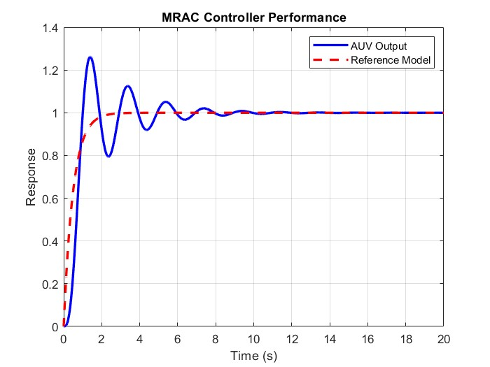

The red dashed curve represents the desired reference output. The blue curve indicates the actual AUV response under MRAC control, which successfully follows the reference model with decreasing oscillations over time.